3.18: a) The time t is 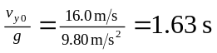.
b) 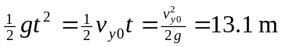.
c) Regardless of how the algebra is done, the time will be twice that found in part (a), or 3.27 s d) 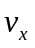is constant at 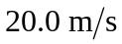, so 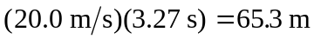.
e)
